**Setting up Splash (Linux)**

Hi everyone,

So unlike Windows & Mac on Linux machines installing Docker & Splash is a bit different, unfortunately there's no GUI like in Windows & Mac to interact with Docker so the only option you have is to use the terminal & launch a couple of commands to get the job done.

**Now, before you even install Docker on your Linux machine please make sure your CPU & including your OS(operating system) are x86_64(also know as 64bit) otherwise you won't be able to use Docker.**

So to install Docker on Linux the first thing you need to do is to check if there are any updates, for that you have to open up the terminal & launch the command:

sudo apt-get update

After that, execute the command below to allow 'apt' to use repositories over the 'HTTPS' protocol:

1. sudo apt-get install \
2. apt-transport-https \
3. ca-certificates \
4. curl \
5. gnupg-agent \
6. software-properties-common

Next, you have to add Docker's official GPG key by executing the following command:

1. curl -fsSL https://download.docker.com/linux/ubuntu/gpg | sudo apt-key add -

Now after that you need to add Docker's repository so later you can install it as you install any other package:

1. sudo add-apt-repository \
2. "deb [arch=amd64] https://download.docker.com/linux/ubuntu \
3. $(lsb_release -cs) \
4. stable"

After you've added the repository, please make sure to launch the command sudo apt-get update again & then to install Docker just launch the command:

1. sudo apt-get install docker-ce docker-ce-cli containerd.io

Now, after you've installed Docker the next step is to Download & Install Splash, for that please open up a new terminal window and then execute the command:

sudo docker pull scrapinghub/splash

Just give it a little bit of time to download Splash from Docker Hub & then after that you can launch Splash by using the following command:

sudo docker run -it -p 8050:8050 scrapinghub/splash

The command above will run Splash instance locally, so after that please don't kill the terminal windows in which you've executed Splash and then open up your browser & navigate to the following address:

http://127.0.0.1:8050

If everything went OK without any errors you should see the following:

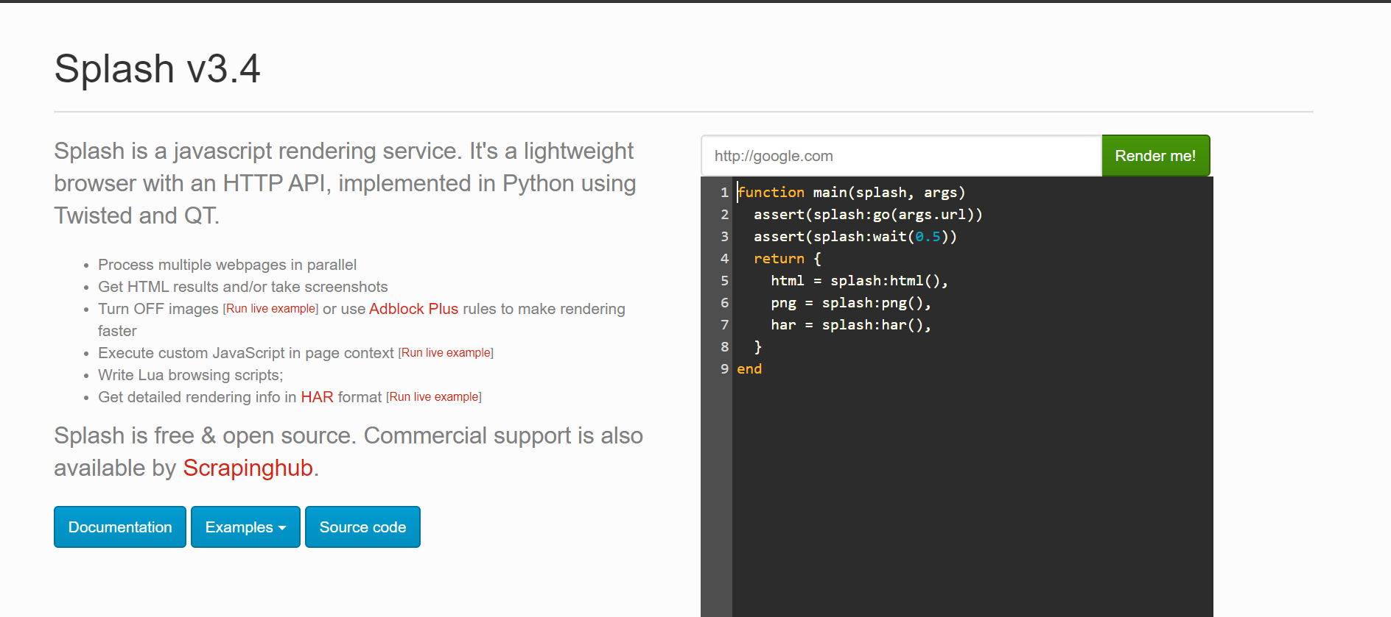

So, that's it... If you have questions or got some issues please let me know in the Q&A area.